**Experiment - 1.2**

**Student Name: Milan Sharma UID: 23MAI10003**

**Branch: ME – CSE - AIML Section/Group: MAI – 1 (A)**

**Semester: 1st Date of Performance: 23 Aug 2023**

**Subject Name: Python Programming Subject Code: 23 CSH 623**

1. **Aim of the Experiment :**

a. Write a python program to find area of a circle.

b. Write a python program to print ASCII Value of a character

1. **Objective of the Experiment :**

To know the formulae and requirement of the functions to calculate area of the circle and find ASCII values of the character.

1. **Algorithm/ Steps for Experiment**

**(a) For Area of Circle –**

**Step 1 -** We have to pass the input using the input() function. The input will be corresponding to the radius of the given circle.

**Step 2 -** The Area of the circle will be calculated by using the formula of the Area = πR2.

**(b) For ASCII Values –**

**Step 1**- Take input of a character from the user

**Step 2**- Declare a variable that will store the ASCII code

**Step 3**- Call ord() function and pass the input as a parameter

**Step 4-**Store the value returned by the function in the variable

**Step 5**- Print the value stored in the variable

1. **Code for Experiment :**
2. **For Area of Circle -**

π = 3.14

Radius = float (input ("Please enter the radius of the given circle: "))

area = π * Radius * Radius

print ("The area of the given circle is: ", area)

1. **To print ASCII Value of a character**

ch = input("Enter any character: ")

print("The ASCII value of char " + ch + " is: ",ord(ch))

1. **Result/Output :**

**(a) For Area of Circle -**

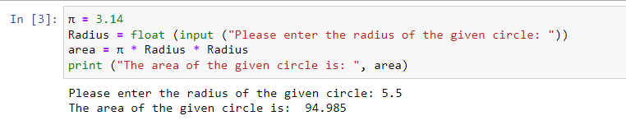

**(b) For ASCII Values –**

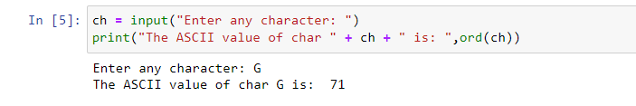

**Learning outcomes (What I have learnt):**

1. Learnt the use of input function.

2. Learnt the use of ord() to find ASCII values

**Evaluation Grid (To be created as per the SOP and Assessment guidelines by the faculty):**

|  |  |  |  |
| --- | --- | --- | --- |
| **Sr. No.** | **Parameters** | **Maximum Marks** | **Marks Obtained** |
| **1.** | **Student Performance**  **(Conduct of experiment)**  **Objectives/Outcomes.** | 12 |  |
| **2.** | **Viva Voce** | 10 |  |
| **3.** | **Submission of Work Sheet**  **(Record)** | 8 |  |